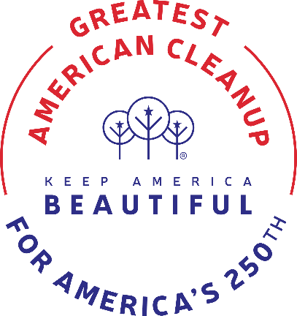
CLEANUP VOLUNTEER FORM
APRIL 21-26

Individual Name: __________________________Phone: ___________________
Group Name: ________________________Contact Person: __________________
Phone: ____________________ (Estimated # of Volunteers In Your Group) _____

Area of Town Where You Will Pick Up Litter the week of April 21-26:
_________________________________________________________________
_____ We don’t have a specific area in mind. Please assign an area to us.
_____ Number of Trash Bags/Gloves Assigned (2 per person)
_____ Number of Safety Vests Assigned (Max 10 per group while they last)
(Vests MUST be returned to the Chamber so they can be reused!)

This form must be filled out and submitted to the Greenwood-Leflore Chamber or to a KGB/KLB Volunteer in order to receive your supplies
YOU MAY PICK UP TRASH BAGS/GLOVES AND VESTS WHILE SUPPLIES LAST DURING THE WEEK OF APRIL 15 AT THE CHAMBER OF COMMERCE
402 Hwy. 82 WEST
NOTE: WE ARE CLOSED ON GOOD FRIDAY, APRIL 18


APRIL 21-26 CLEANUP WEEK
THANK YOU FOR VOLUNTEERING!

PLEASE HELP US WITH A FOLLOW UP:
Please TAKE AND SUBMIT pictures of your group as you clean up so we can SHARE your progress/hard work! Also, please keep up with the number of trash bags you collect/throw away. If you don’t use all of your supplies, please RETURN THEM to us so we can recycle and use them again!
We will use these numbers for our Keep America Beautiful report. THANK YOU! You can email pictures and data to info@greenwoodms.com no later than May 5, 2025.
You can pick up your supplies during the week of April 14. Please note we are CLOSED on Friday, April 18 for Good Friday Holiday.

THANK YOU for taking time to help clean our community. When we all work together for a more beautiful place to live, we are all happier, more connected and inspired! TOGETHER, we can make Greenwood/Leflore County a place we are proud to call home!

